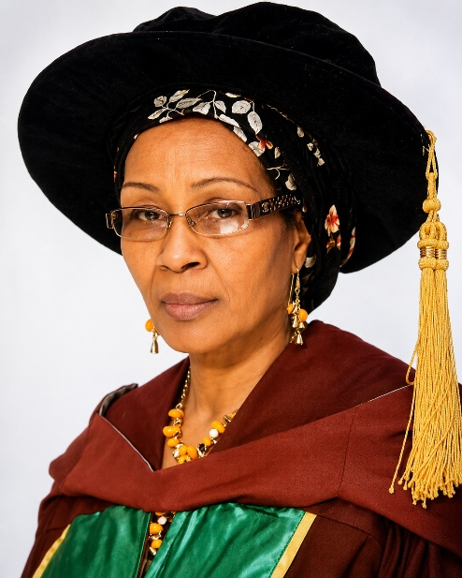
Professor Inuwa Hajiya Mairo
Professor Inuwa Hajiya Mairo Yesufu is a distinguished Nigerian biochemist, academic, and biotechnology research leader whose five-decade career spans university teaching, pharmaceutical industry leadership, and pioneering scientific research. She was Director of the Centre for Biotechnology Research and Training (CBRT), which also hosts the National Biotechnology Development Agency's (NABDA) Northwest Zonal Office.
Professor Inuwa's academic journey reflects sustained excellence. She earned her BSc (Hons) in Biochemistry from Ahmadu Bello University in 1975 as the Best Student and a University Scholar, followed by an MSc in Biochemistry from the same institution (1977–1979) on a University Scholarship. She then pursued doctoral studies at the University of Glasgow, completing her PhD in Biochemistry with a focus on Plant Gene Expression in under three years (1986–1989) as a Commonwealth Academic Staff Award recipient after which she was made a General Council Member of University of Glasgow in 1989. Her career began at ABU in 1976 as a Graduate Assistant, rising steadily through the ranks to become a Professor in October 2012.
Notably, between 1991 and 2002, she stepped outside academia to serve as Quality, Research and Development Executive at Glaxo Nigeria Plc (now Evans Medical Plc) in Lagos, where she led research and development of pharmaceutical and health food products, sourced raw and packaging materials, and ensured factory quality assurance in line with Good Manufacturing Practice and ISO standards. This industry stint produced a notable innovation: the development of pregelatinised maize starch as a tablet excipient in 1998.
Returning fully to academia in 2002, Professor Inuwa has held key leadership roles, including Head of the Department of Biochemistry (2009–2014), Deputy Centre Leader at the African Centre for Excellence in Neglected Tropical Diseases and Forensic Biotechnology (2014–2018), and University SIWES Coordinator (2003–2010). She was Director of CBRT since 2017-2021.
Her research portfolio is broad, spanning pediatric nutrition, veterinary biochemistry, trace element metabolism, DNA methylation, and most extensively, molecular and genetic diversity analysis in crops such as maize and cotton, medicinal plants, sickle cell genotypes, and neglected tropical diseases including trypanosomiasis, rabies, filariasis, and onchocerciasis. She has supervised roughly 100 postgraduate students, including 70 MSc and 30 PhD candidates. Professor Inuwa is an active member of professional bodies such as the Nigerian Society of Biochemistry and Molecular Biology, the Biotechnology Society of Nigeria, and the Nutrition Society of Nigeria, and has contributed to national initiatives like the UNICEF community assessment of malnutrition and zinc deficiency in northwest Nigeria.

